Final Project Report - Computer Networks
Submitted by: Lucas Boet & Maor Cohen
Course: Computer Networks

Part 1: Packet Packing and Capture

1.1 CSV File Creation
The input file, Lucas_Maor_http_input.csv, contains Application Layer messages required for the simulation.
- Method of Creation: The file was created manually/based on the provided template to match the required format for HTTP messages.
- File Content: It simulates a conversation between a client browser (client_browser) and a web server (web_server), containing GET requests and HTTP responses, including timestamps and message IDs.

1.2 Packet Packing Process (Jupyter Notebook)
We used the ComputerNetworkProject.ipynb notebook to simulate the Encapsulation process of the data across TCP/IP layers.
The process performed in the notebook included:
- Loading Data: Reading the CSV file using the pandas library.
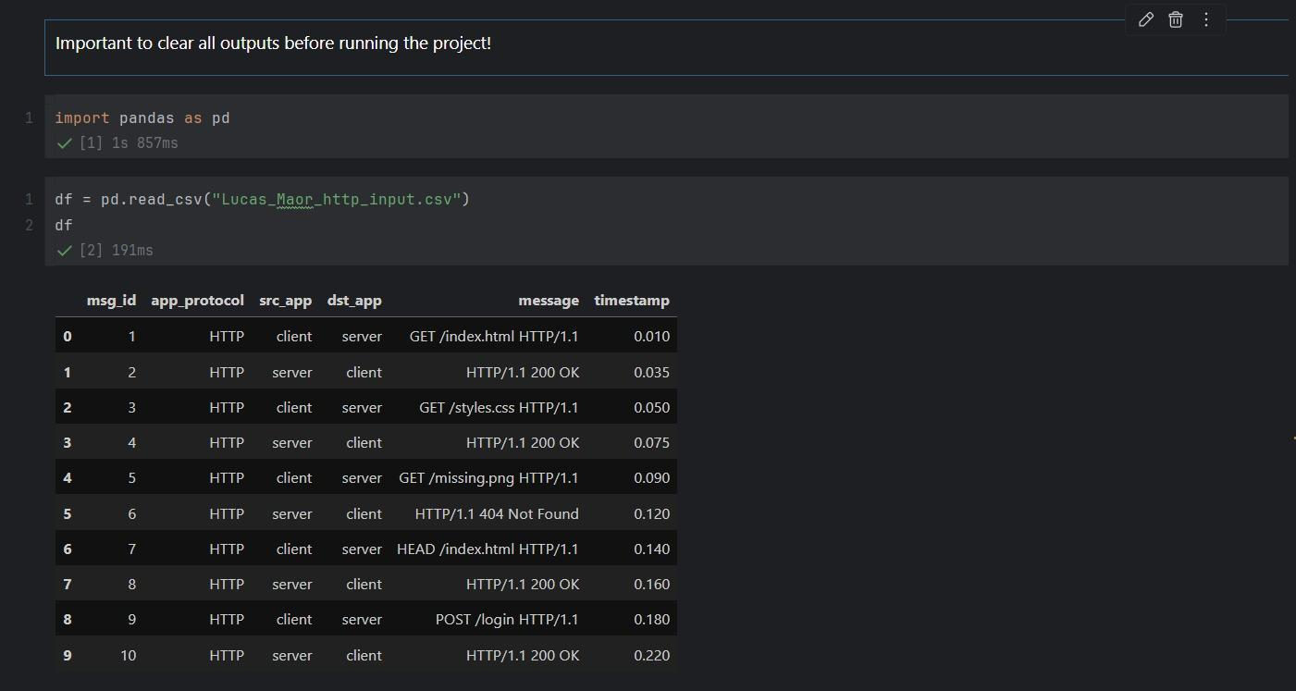
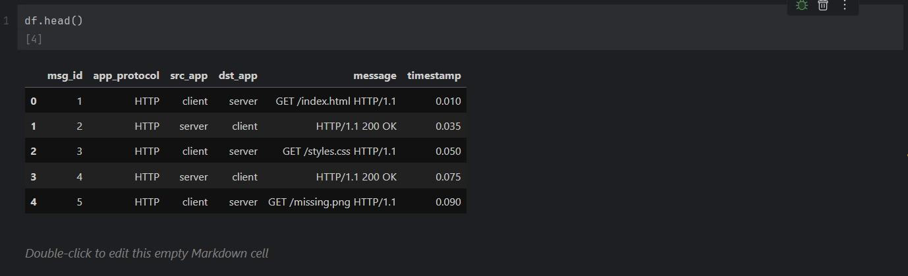
- Packet Simulation: Converting each row in the file into a packet structure by adding the appropriate Headers for each layer:
  - Application Layer: The raw data (e.g., the HTTP message).
  - Transport Layer: Adding Source and Destination Ports (e.g., Port 80 for HTTP).
  - Network Layer: Adding Source and Destination IP addresses.
  - Link Layer: Adding MAC addresses.
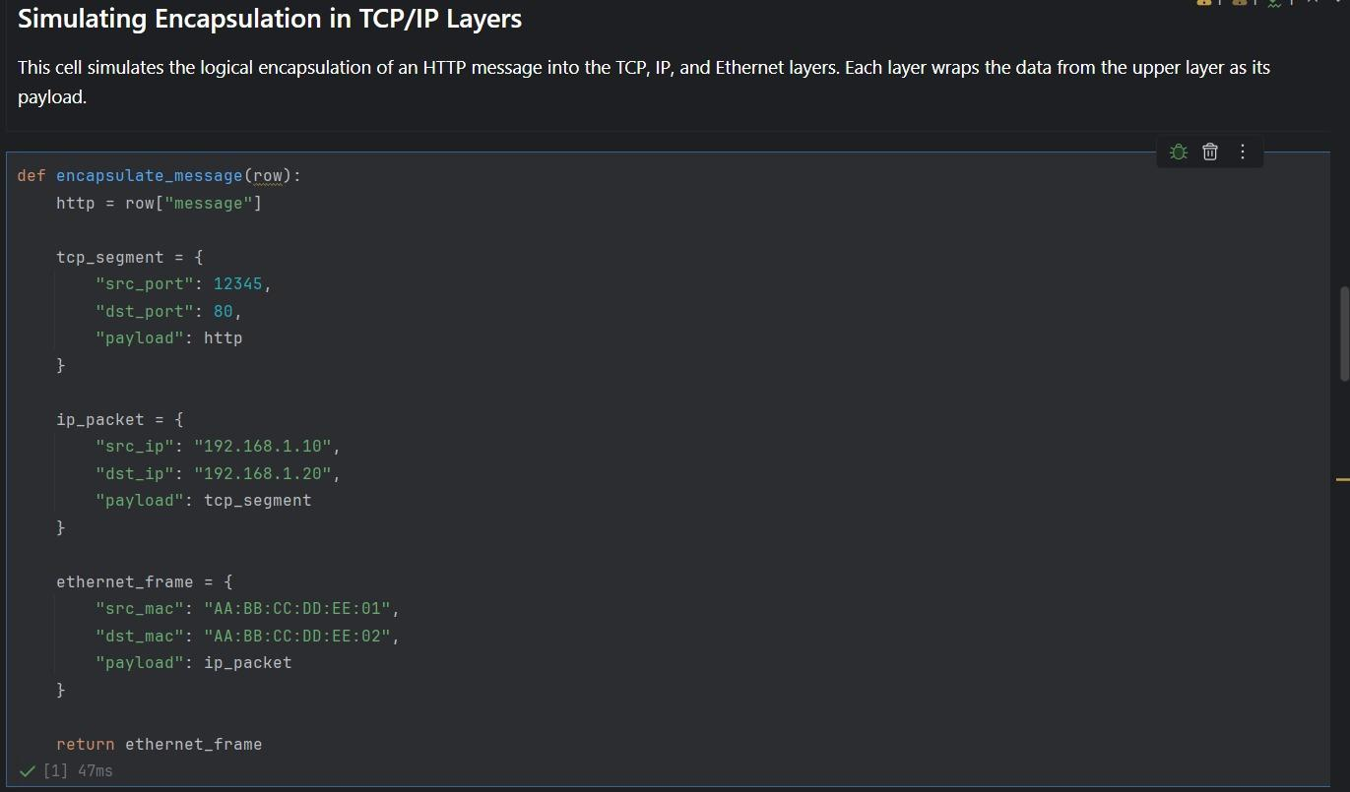
- Traffic Generation: Sending the processed data over the network to be captured by Wireshark.
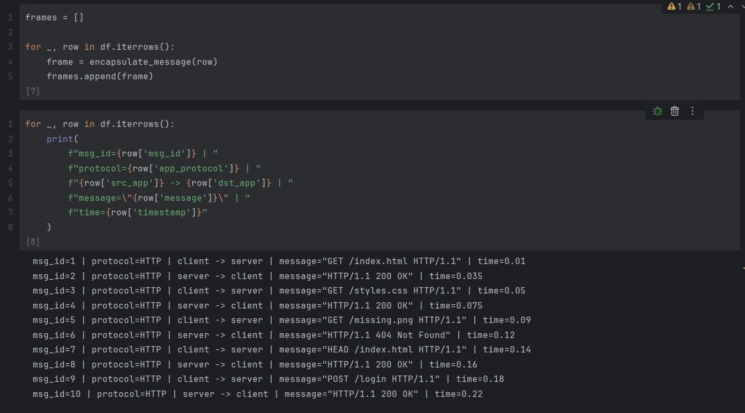

1.3 Capture Process (Wireshark)
To capture the traffic generated by the notebook, we performed the following steps:
- Launched Wireshark and selected the active network interface (Loopback Adapter / WiFi).
- Applied a capture filter: tcp port 80 (to isolate the HTTP traffic generated by the notebook).
- Ran the Jupyter notebook cells to generate traffic in real-time.
- Stopped the capture and saved the file as Lucas_Maor_http_capture.pcap.

1.4 Wireshark Analysis
Analyzing the capture file reveals the traffic generated by our script.
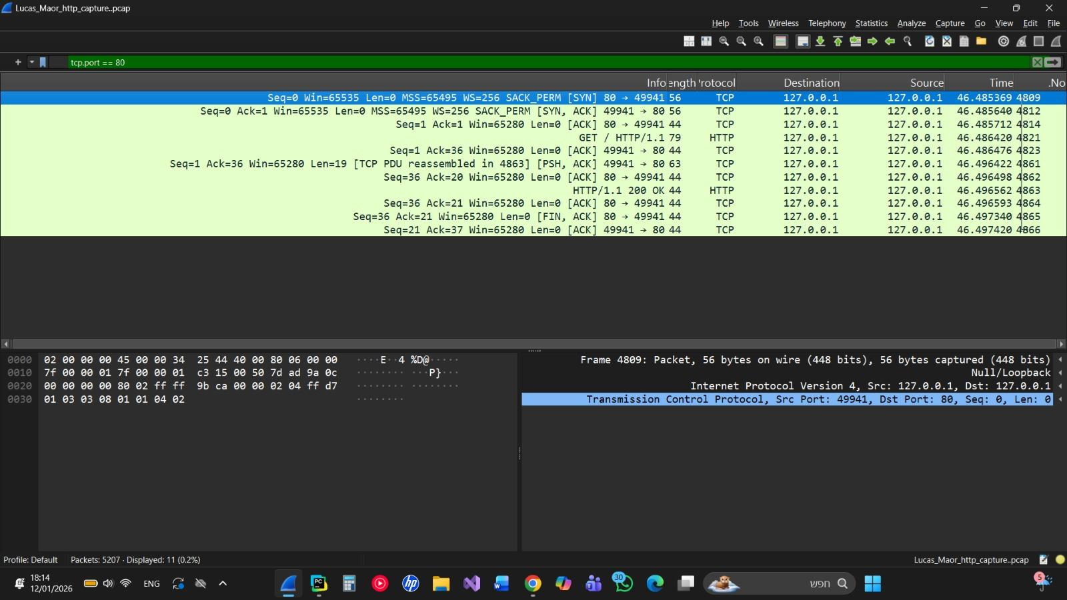
Findings:
- Connection Establishment: We can observe the TCP Three-Way Handshake (SYN, SYN-ACK, ACK flags) at the beginning of the conversation.
- Data Transfer: Following the handshake, we see PSH, ACK packets containing the HTTP payload (e.g., GET /index.html) corresponding to the messages in our CSV file.
- Connection Termination: Finally, the connection is closed using FIN packets.

Part 2: Chat Application (Client-Server) & Traffic Analysis

2.1 System Overview and Code Structure
The system is a Chat Application based on TCP Sockets, allowing multiple clients to communicate via a central server. The system supports concurrency (Multithreading) and includes a Graphical User Interface (GUI) for the client.
Server Structure (server.py):
- Socket Management: The server listens on a specific port and accepts incoming connections using socket.accept().
- Multithreading: For every client that connects, the server spawns a new thread. This satisfies the requirement to handle at least 5 clients simultaneously.
- Client Management: The server maintains a mapping of connected users (Username <-> Socket) to route messages correctly.
- Message Routing: When the server receives a message, it parses the destination and forwards it to the specific client.
Client Structure (client_gui.py):
- Communication: The client connects to the server using the defined IP and Port.
- GUI (Bonus Feature): We implemented a graphical interface (using tkinter) that allows users to type messages, view chat history, and select recipients easily. This replaces the standard textual interface.
- Listening Thread: The client runs a separate thread to constantly listen for incoming messages from the server without freezing the GUI.
Calculator Utility (calculatur.py):
- An auxiliary module added to the project to perform simple calculations.

2.2 Installation and Running Instructions
You can run the system using an IDE (like PyCharm) or directly via the terminal.
Option 1: Running via PyCharm (IDE)
- Start the Server:
  - Open the project folder in PyCharm.
  - Right-click on the server.py file and select Run 'server'.
  - The console will display a message indicating the server is listening.
- Start Clients:
  - Right-click on the client_gui.py file and select Run 'client_gui'.
  - To connect multiple users, simply run the client_gui.py file again for each new user (PyCharm allows parallel execution).
  - A separate window will open for every instance. Enter a unique username and click Connect.
Option 2: Running via Terminal (Command Line)
- Start the Server:
  - Open a terminal/command prompt in the project folder.
  - Run the command: python server.py
- Start Clients:
  - Open a new terminal window for each client you want to connect.
  - Run the command: python client_gui.py
  - Enter a unique username in the window that appears and click Connect.

2.3 Input and Output Examples
Scenario: Five users connect to the server in the specific order: Maor, Lucas, Bob, Emilia and Moshiko. Afterward, Lucas sends a private message to Maor.
Step 1: Connection Sequence
- Maor Connects:
- Action: Run client_gui.py.
- Output: The Client Login window opens.
- Input: User enters the name maor and clicks Connect.
- Result: The window updates to the main Chat Interface, displaying a "Connected" status.

- Lucas Connects (same process for the other three clients):
- Action: Run client_gui.py again (new instance).
- Output: A second Client Login window opens.
- Input: User enters the name lucas and clicks Connect.
- Result: Lucas's chat interface appears.

Step 2: Message Exchange
- Action: Lucas wants to send a private message to maor.
- Lucas's Input: In the message box, lucas types: maor: Hello! (or selects Maor as the recipient).
- Server Processing: The server parses the message, identifies Maor as the target, and routes the data only to him.
- Maor's Output: maor sees: [lucas]: Hello! in his chat window.
- Bob's Output: bob sees nothing, as the message was private.

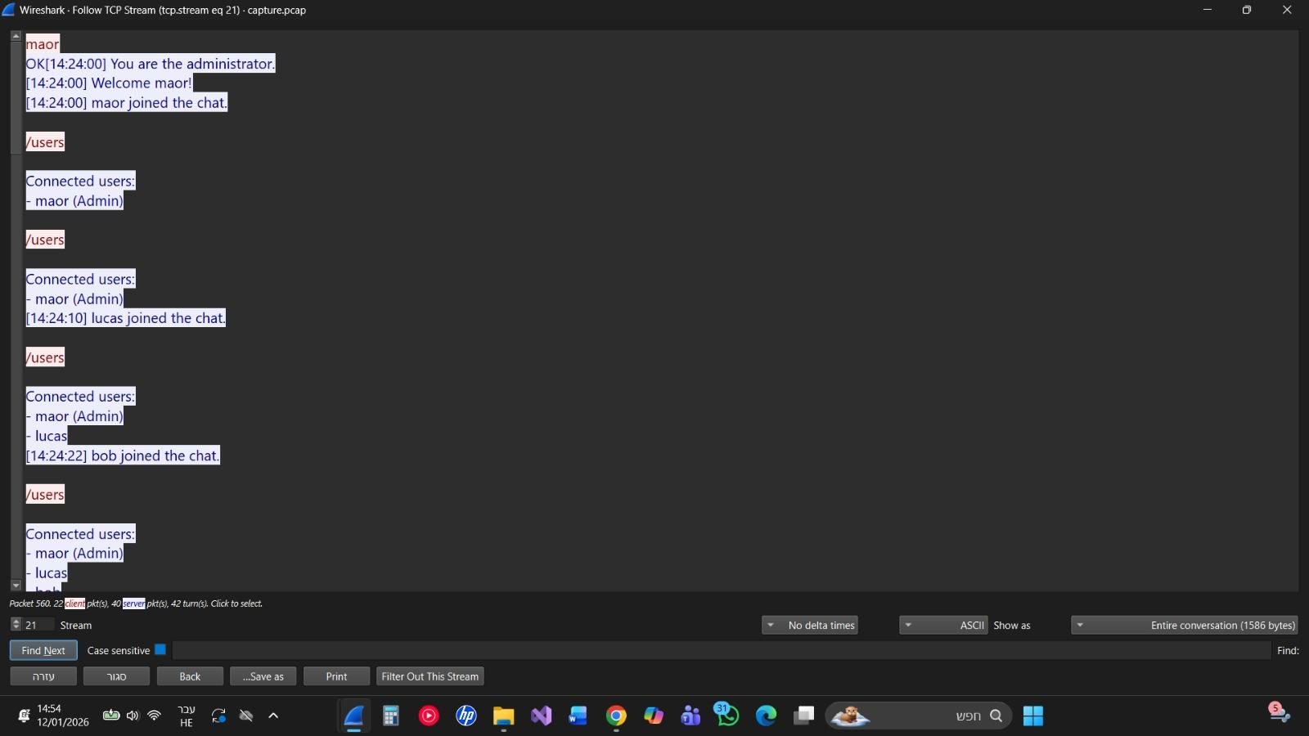

2.4 Application Traffic Analysis (Wireshark)
In the capture file capture.pcap, we can observe the communication between the clients and the server.
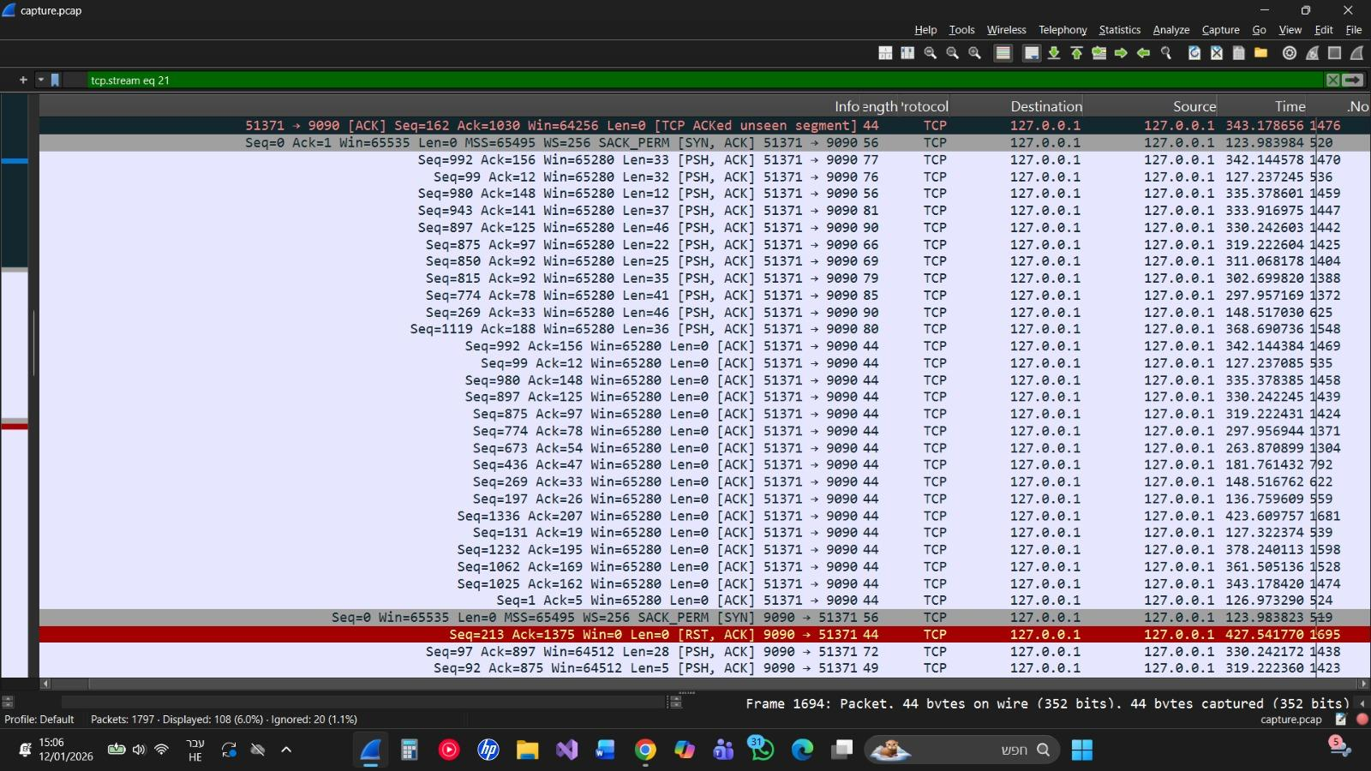
Analysis:
- TCP Handshake: We observe the standard SYN, SYN-ACK, ACK sequence when a new client connects to the server.
- Data Transmission: When a message is sent via the GUI, Wireshark captures PSH, ACK packets. The "Data" section of these packets contains the text message sent between users.
- Network Layer: The Source and Destination IP addresses correspond to the machine running the clients and server (likely localhost / 127.0.0.1 or the LAN IP).

AI Usage Description

- Goals: We utilized AI to assist in understanding Python Socket syntax, debugging multithreading logic, and designing the structure of the Client GUI.
- Sample Prompts:
  - "How to create a multi-threaded TCP server in Python?"
  - "How to build a simple chat GUI using tkinter?"
  - "Explain the TCP 3-way handshake as seen in Wireshark."

Deliverables Checklist
- Part 1: CSV file (Lucas_Maor_http_input.csv), Jupyter Notebook (ComputerNetworkProject.ipynb), and Wireshark Capture (Lucas_Maor_http_capture.pcap).
- Part 2: Full Code (server.py, client_gui.py, client.py, calculatur.py) and Application Capture (capture.pcap).
- Report: This document.

